The Invisible College Trilogy
A Mystery Adventure for Young Adults by Owen Knight
‘1984 Meets the Book of Revelation’
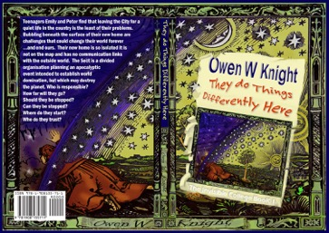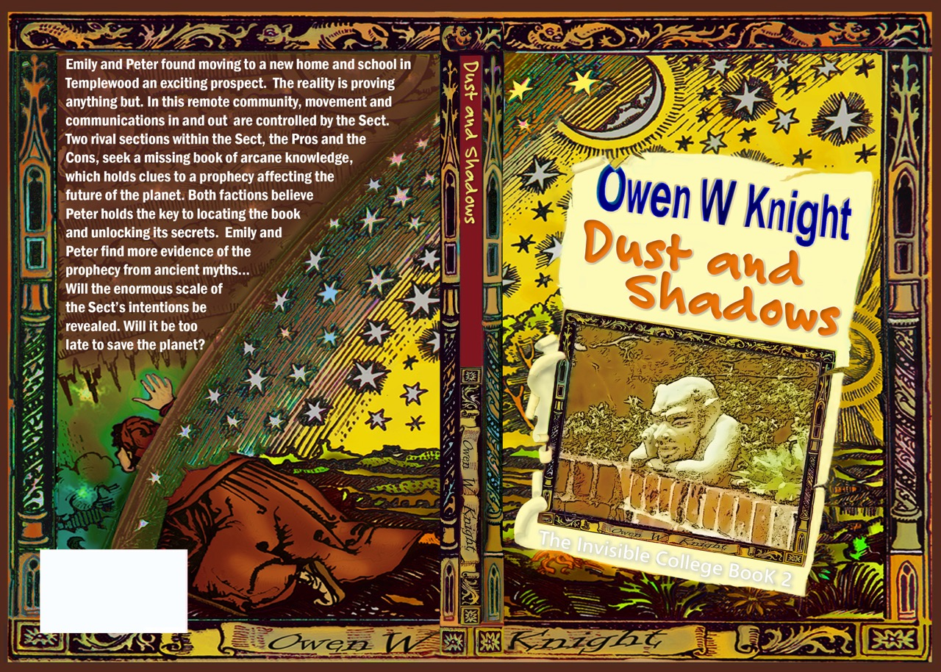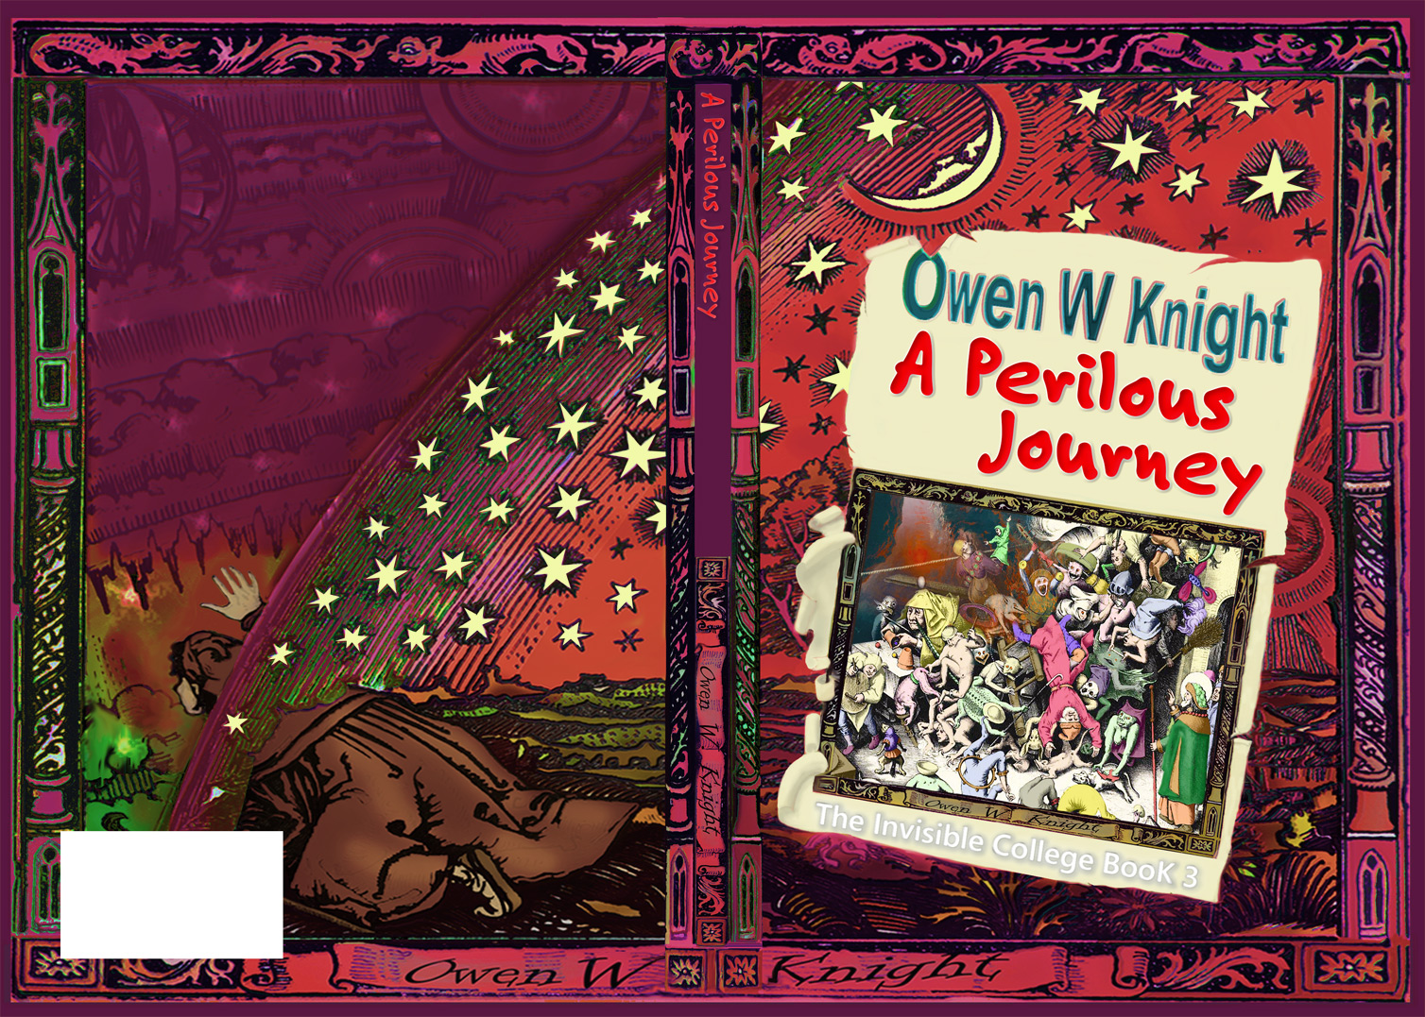

The Story
When the Walden family moves to Templewood, teenagers Emily and Peter find that leaving the City for ‘a quieter life in the country’ is the least of their problems. Bubbling beneath the surface of their new home are challenges that could change their world forever, and end ours.
Templewood is an isolated community that is absent from maps and has no communications links with the outside world. The village is home to the Sect, a divided organisation planning an apocalyptic event intended to establish world domination, but which may destroy the planet.
Emily and Peter’s arrival is no accident; their mother and father may know more than they admit. The Sect has identified Peter as the chosen individual who holds the key to revealing the final piece of information necessary to trigger a world-changing event. One by one, mysteries are uncovered, until the terrifying objective of the Sect becomes clear.
There is little time in which to find who is responsible. How far will they go? Should they be stopped? Can they be stopped? If you were the only ones who could save the world, where would you begin? Who would you trust?

Genres, Themes and Sources
Adult Fiction, Teenage Fiction, Literary Fiction, Science Fiction, Dystopia, Adventure, Mystery, Conspiracy, Coming of Age.
Themes include the quest for hidden knowledge, use and abuse of knowledge and power, moral values and choices, environmental and ethical issues. A secondary theme is the influence of music and the landscape on our lives.
The Invisible College is a 21st century conspiracy story, with elements of scientific fantasy and hints of esoteric mystery, based on thoroughly researched content from documented history, myths, legends and ancient beliefs. The mystic elements remain in the mind of the imaginative reader. Clues to the imminent threat are found in sources as diverse as the Norse legends, Greek and Egyptian Mysteries and the Bible.

Praise for The Invisible College Trilogy
‘In this remarkable trilogy, Owen Knight blends mystery, suspense and character with an exploration of profound moral, political and social issues. Is personal freedom an illusion? What should be the limits of state power? Whom can we trust? Can dictatorship ever be benign? What price would we be prepared to pay for a world of comfort, peace and equality? The story and the issues should engage readers young and old, leading them through a mysterious world of sectarian division and control to asking fundamental questions about life and values.'
Mel Thompson, Best-selling author of books on religion, philosophy and ethics.
The Invisible College Trilogy
A Mystery Adventure for Young Adults by Owen Knight
‘1984 Meets the Book of Revelation’
USP and Target Market
The unique feature is the truly original world-changing event and conspiracy, relevant to a global audience. The book can be read as an adventure novel, with or without awareness of the literary and historical allusions. It will appeal to adults and young adults from 11 years.
Why the Book Will Appeal to Adults and Young Adults
A mystery story and an adventure, with major themes of conspiracy, a hidden community, ancient myths and mysteries, the quest for hidden knowledge and treasure, moral values and freedom of choice. The trilogy can be read simply as a conspiracy novel, or enjoyed for the hints of paranormal possibilities. The trilogy will make an excellent film adaption.

Overview of Trilogy
Book 1. They Do Things Differently Here. Discovery of the isolation of the village and the control exerted over its inhabitants.
Book 2. Dust and Shadows. Revelation of the prophecy of a world-changing event, its nature and scale, and the connection to the family.
Book 3. A Perilous Journey. The battle to save the planet and the human race.
The trilogy begins by emphasising the outward ordinariness of the village. The pace accelerates as the mystery is uncovered. The style moves from narrative towards dialogue, then action. Passages of formal and Gothic writing reflect the community’s isolation and a growing awareness that all is not normal.

Author Information and Background to Writing the Book
First novel(s). Previously unpublished. Now a full time writer and photographer, with other adult and young adult ideas in progress.
I spent many years in business, as a director of a software company and as an independent consultant. The experience provided me with a background of envisaging change, producing scenarios of differing outcomes and developing pragmatic solutions: useful qualities to apply to creative fiction (which is what many of my business reports were).
The original idea for the trilogy came from walking in the woods with my children and imagining that treasure could be found beneath the roots of trees felled by a storm. This led to the idea of the discovery of a prophecy of an impending global catastrophe and the resulting consequences.
The Invisible College has taken ten years to develop and complete. I spent much time researching sources that give credibility to the story as an interpretation of historic legends, including the Ancient Mysteries, the Book of Revelation and Norse Myths. I discovered books describing historical documents, myths and legends supporting the existence of the central prophecy of the story.
A website and blog are located at www.owenknight.com.

Publication Details
Book 1, They Do Things Differently Here. Published August 2015.
Paperback: ISBN 978-1908135711 eBook edition:ISBN 978-1908135728
Book 2, Dust and Shadows. Published February 2016.
Paperback: ISBN 978-1908135148 eBook edition - ISBN 978-1908135704
Book 3, A Perilous Journey, published September 2016

